
UNIVERSITY OF MINES AND TECHNOLOGY (UMaT)
FACULTY OF COMPUTING AND MATHEMATICAL SCIENCES
DEPARTMENT OF Computer Science and Engineering

STADIUM NETWORK SECURITY ASSESSMENT
A Comprehensive Security Report on Perimeter Identification,
Network Infrastructure, and Human Operational Factors

SUBMITTED BY:
Sulemana Akunatu Abdul Jalil | — FCM.41.018.245.23
Mohammed Abdallah | — FCM.41.018.175.23
Arthur Fosu Samuel | — FCM.41.018.070.23
Narteh Benjamin Kwame Tei | — FCM.41.018.183.23
Osei Michael Nyamekye | — FCM.41.018.218.23
Mushinat Mukaila | — FCM.41.018.179.23
Adu Martin Yeboah | — FCM.41.018.013.23
Ernest Dadzie | — FCM.41.018.118.23
Danso Adobea Josephine | — FCM.41.018.120.23

SUBMITTED TO:
Department of Computer Science and Engineering

Date: February 2026
Tarkwa, Ghana

EXECUTIVE SUMMARY
This report presents a network security assessment for a 20,000-capacity stadium. It covers three main areas: the physical and logical security perimeter, the wireless network boundary, and human factors that could affect security.
The stadium is divided into ten security zones, each with a risk level and access controls. Key risks have been identified at pedestrian gates, service vehicle checkpoints, the Network Operations Centre (NOC), and through social engineering attacks on staff.
Recommendations are based on three security layers: physical protection, network control, and human awareness.

SECTION 1: PERIMETER IDENTIFICATION

1.1 Physical Perimeter Definition
The stadium perimeter includes both visible physical boundaries and invisible logical boundaries that protect people, infrastructure, and digital systems.
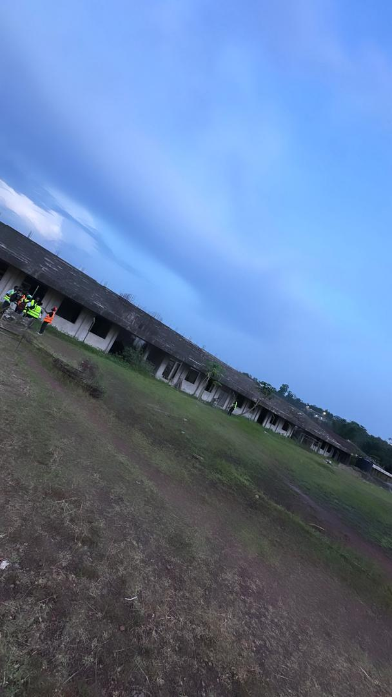
Figure 1: Site visit photos of the stadium facility
1.1.1 Visible Physical Boundaries
- Stadium outer fence and walls
- Parking lot barriers at all vehicle entry points
- Security checkpoints at all entry gates
- Ticket control points at spectator entrances
- Main stadium gates with security guards on patrol
1.1.2 Invisible Logical Boundaries
- Wireless network coverage limits — signals must not go outside the stadium
- CCTV monitoring zones covering all areas of the stadium
- Network firewall boundaries separating all security zones
- Security patrol areas monitored by the control room

1.2 Security Zone Classification
The stadium is divided into ten security zones (Z1 to Z10). Each zone has a different security level based on who is allowed inside and what is there.
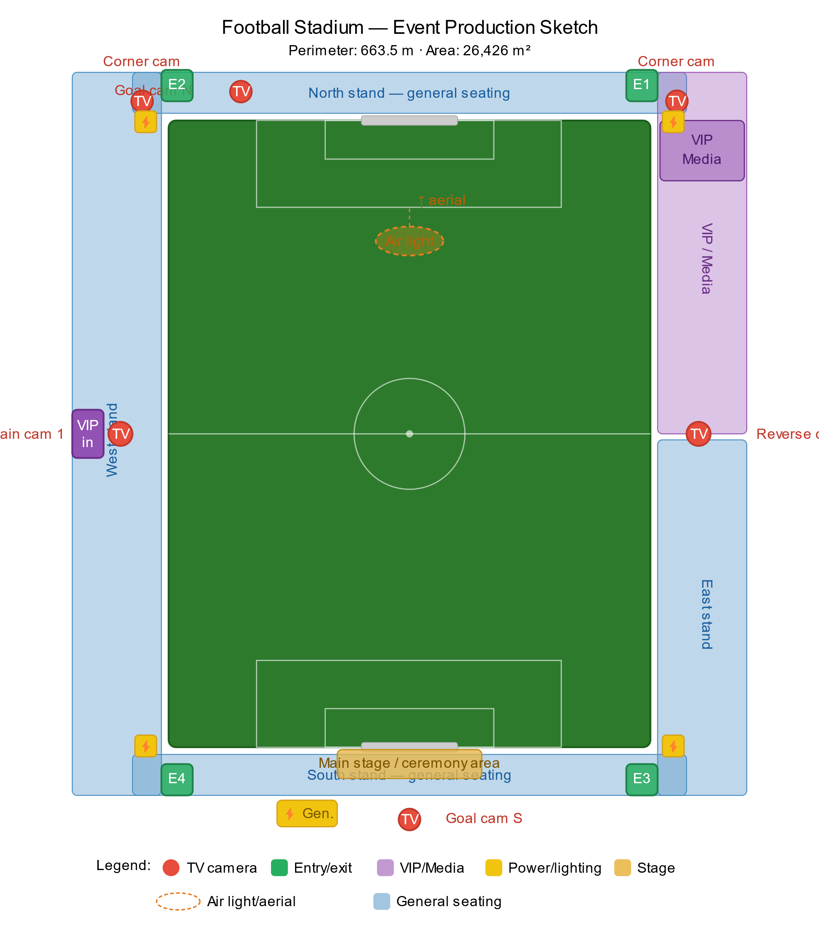
Figure 2: Stadium zone layout diagram

Zone | Name | Authorized Personnel | Risk Level | Network
Z1 | Public Forecourt | General public | LOW | VLAN 100
Z2 | Ticketed Concourse | Ticket holders, stewards | MEDIUM | VLAN 100
Z3 | Seating Bowl | Ticket holders, stewards | MEDIUM | VLAN 100
Z4 | VIP / Hospitality | VIP guests, hospitality staff | MEDIUM | VLAN 100
Z5 | Media / Press Box | Accredited media, IT staff | HIGH | VLAN 40
Z6 | Operations Control Room | Authorized operations staff | CRITICAL | VLAN 30
Z7 | Server Room / NOC | IT and security staff only | CRITICAL | VLAN 10
Z8 | Playing Field | Teams, officials, authorized staff | HIGH | VLAN 30
Z9 | Perimeter Service Road | Vendors, emergency services | HIGH | VLAN 60
Z10 | Parking Areas | Ticket holders, badged staff | MEDIUM | VLAN 100
Table 1: Stadium Security Zone Classification

1.3 Entry Points and Access Control Mechanisms
1.3.1 Pedestrian Entry Gates
Pedestrian gates are distributed around the stadium perimeter:
- Gates A, B, and C — Main gates for the majority of spectators
- Gates D, E, F, and G — Secondary gates for additional access
- Gate H — Emergency egress only; not used for standard entry
1.3.2 Vehicle Entry Points
- V1 North — Primary vehicle access for VIP and official vehicles
- V2 South Service Gate — Primary access for all vendor, catering, and delivery vehicles
- V3 Emergency Access West — Secondary access reserved for emergency services
1.3.3 Access Control Technologies

Zone | Primary Control Method | Secondary Control Method
Z1 — Public Forecourt | None (open public access) | Uniformed steward patrols
Z2 — Ticketed Concourse | Barcode / NFC ticket scanning at turnstile | Visual bag search by stewards
Z4 — VIP Hospitality | RFID smart card + PIN keypad | Biometric fingerprint scan
Z6 — Control Room | RFID card + biometric fingerprint | Video intercom, guard approval
Z7 — Server Room / NOC | Iris scan + PIN + RFID card (3-factor) | Mantrap airlock — single occupancy
Table 2: Access Control Technologies by Zone

1.4 Highest Risk Access Points
Not all entry points carry the same risk. These five locations need the most attention:
Gate A — North Main Entrance [CRITICAL]
This is the busiest entrance with high crowd density. There is risk of ticket fraud and crowd surge. Multiple ticket scanners, security personnel, CCTV monitoring, and metal detectors are required.
V2 — South Service Gate [CRITICAL]
All vendor and delivery vehicles use this gate. A fake delivery can be used to sneak in unauthorized people or dangerous devices. All deliveries must be pre-registered. Every driver must show photo identification.
Z7 — Server Room / NOC [CRITICAL]
If someone gets inside the NOC, they can control the entire stadium network including cameras, PA system, and emergency communications. Three-factor authentication and a security door are required.
Gate G — Media West [HIGH]
Media passes are easy to copy. Camera bags can hide unauthorized devices. Media staff also have access to the pitch side. All media credentials must be verified and all equipment must be checked before entry.
V3 — Emergency Access West [HIGH]
This gate is opened with a key on request. An attacker pretending to be emergency services can trick a guard into opening it. Guards must verify all emergency callouts with the control room before opening.

1.5 Surveillance and Monitoring
CCTV cameras are deployed across the stadium. Each camera is classified by its security function.

Location | Qty | Camera Type | Function | Classification
Entry Gates (A–D) | 24 | Fixed 4K bullet | Entry monitoring | PREVENTIVE
Forecourts (all sides) | 16 | PTZ dome 4K | Crowd monitoring | PREVENTIVE
Concourse (all levels) | 60 | Fisheye 360° | Full coverage | DETECTIVE
Seating Bowl | 20 | PTZ long-range | Crowd detection | DETECTIVE
NOC / Server Room | 8 | Fixed 4K internal | Physical security | DETECTIVE
Parking Areas | 30 | PTZ + pole-mounted | Vehicle monitoring | CORRECTIVE
Emergency Exits | 24 | Sensor-triggered | Door alarm coverage | CORRECTIVE
Stairwells | 40 | Fixed 2MP dome | Flow monitoring | DETECTIVE
Vehicle Checkpoints | 18 | ANPR + overview | Plate recognition | PREVENTIVE
Roof / Plant Access | 12 | Motion-activated | Intrusion detection | DETECTIVE
VIP Suite Corridors | 8 | Fixed 4K dome | Access monitoring | DETECTIVE
Perimeter Service Road | 6 | PTZ wide-angle | Vehicle and staff checks | DETECTIVE
Table 3: Camera Deployment and Classification (Total: 266 cameras)
Camera classifications are defined as follows:
- PREVENTIVE: Cameras that stop incidents before they happen
- DETECTIVE: Cameras that spot incidents as they happen
- CORRECTIVE: Cameras that respond and help recover after an incident
1.5.1 Identified Blind Spots
These areas have reduced camera visibility and need to be fixed:
- Behind pillars — add cameras at the base of each pillar
- Bathroom entrances — wide-angle cameras in corridors leading to these areas
- Under vehicle areas at entry gates — use mirror scanners
- Rooftop areas — motion-activated cameras on maintenance walkways
- Emergency exit exteriors — cameras covering the area around every emergency door
1.5.2 Lighting Standards
Proper lighting must be installed in the following areas to support camera performance and staff safety:
- Parking lots
- Entry gates and concourse areas
- Emergency exits and hallways
- Staircases and restricted zone corridors
- Server room and NOC

SECTION 2: NETWORK AND WIRELESS PERIMETER

2.1 Network Infrastructure Overview
The stadium network is built on a three-layer design (core, distribution, and access), housed in the NOC in Zone 7. It uses separate VLANs to carry different types of network traffic.

VLAN ID | Name | IP Subnet | Purpose
10 | IT Management | 10.0.10.0/24 | NOC and IT staff management access
20 | Staff WiFi | 10.0.20.0/23 | All operational staff wireless access
30 | Operations | 10.0.30.0/24 | Control room and operations systems
40 | Media | 10.0.40.0/24 | Broadcast and press equipment
50 | Point of Sale | 10.0.50.0/24 | Retail and catering POS terminals (PCI-DSS scoped)
60 | Emergency | 10.0.60.0/24 | Emergency services communications
70 | CCTV | 10.0.70.0/24 | All surveillance cameras and NVRs
80 | VoIP | 10.0.80.0/24 | Internal telephony and PA systems
100 | Public WIFI | 192.168.100.0/22 | Fan-facing public hotspot (Internet only)
200 | DMZ | 172.16.200.0/24 | Public-facing servers (ticketing, web)
999 | Blackhole | N/A | All unauthorized/unrecognized device traffic dropped here
Table 4: VLAN Design Summary

2.2 Wireless Signal Boundary Management
WiFi signals can pass through walls and must be controlled carefully to prevent them from leaking outside the stadium.
2.2.1 Signal Containment Methods
- Directional antennas point signals inward, away from streets
- Transmit power is reduced to the minimum needed
- WPA3 encryption enabled on all staff wireless networks
- Staff network names are hidden — not visible when scanning for networks
- MAC address filtering used to block unknown devices
- Wireless intrusion detection system (WIDS) deployed
- Regular network scanning to detect any unauthorized access points

2.3 Rogue Access Point Detection and Response
A rogue access point is an unauthorized WiFi hotspot set up by an attacker to steal data from spectators or staff. It is one of the biggest wireless threats at the stadium.
2.3.1 Rogue Detection via Infrastructure
- All access points scan for unknown or suspicious networks while still serving users
- Any network pretending to be the official WiFi is automatically blocked
- Alerts are sent to the NOC immediately upon detection
- Unused network ports are disabled to prevent unauthorized connections
2.3.2 Wired Rogue Device Detection
- All devices connecting to the network are verified before access is granted
- Any unrecognized device on a network port generates an alert and is blocked
- All switch ports with no active device are disabled
2.3.3 Public WiFi Security Controls
- Public WiFi is on a separate guest network (VLAN 100), completely isolated from staff systems
- Every public user must accept terms of service before browsing
- Bandwidth is limited per device to prevent abuse
- Network firewall filtering blocks access to harmful websites
- Client isolation is enforced — fans cannot see or reach other devices on the network
- Public network is completely separated from all staff and operations networks
2.3.4 Signal Spillover Risk by Zone

Zone | Spillover Risk | Cause | Mitigation
North Forecourt (Z1) | HIGH | Adjacent to public street | Directional antennas + TPC reduction
Parking Areas (Z10) | MEDIUM | Open air, distant from core | Pole-mounted APs with inward facing antennas
VIP Suite Windows | HIGH | Large glass area facing exterior | RF shielding film on all external windows
Rooftop Plant Area | LOW | Elevated, minimal occupancy | Minimal AP presence; motion-triggered only
Table 5: WiFi Signal Spillover Risk Assessment

SECTION 3: HUMAN OPERATIONAL FACTORS

3.1 Actor Classification and Network Trust Levels
Different people in the stadium have different levels of access and trust based on their role.

Actor Type | Zone Access | VLAN Assignment | Trust Level | Network Policy
General Spectators | Z1–Z3 | VLAN 100 | UNTRUSTED | Internet only, client isolation
VIP Guests | Z1–Z4 | VLAN 100 | LOW TRUST | Internet only, managed bandwidth
Stewards | Z1–Z3, Z8 | VLAN 20 | MEDIUM | Event systems only
Operations Staff | Z2–Z6, Z9 | VLAN 30 | TRUSTED | Operations network, wired preferred
IT / NOC Staff | All zones | VLAN 10 | HIGH TRUST | Full network access
Security Staff | All zones | VLAN 20+ | HIGH TRUST | CCTV and comms access
Media / Broadcast Crew | Z5, Z8 | VLAN 40 | MEDIUM | Media VLAN, outbound only
F&B Vendors | Z2, Z3 | VLAN 50 | LOW TRUST | POS terminals only
Contractors | Z9, limited | Isolated | UNTRUSTED | No general network access
Emergency Services | All zones | VLAN 60 | HIGH (vetted) | Emergency comms only
Delivery Drivers | Z9 only | None | UNTRUSTED | No network access granted
Table 6: Actor Classification and Trust Levels

3.2 Social Engineering Threat Analysis
Social engineering means tricking people instead of hacking machines. These are the main threats identified at this stadium.
Scenario 1: IT Staff Impersonation [CRITICAL]
An attacker pretends to be an IT technician and requests access to the server room for maintenance. A staff member may allow access without proper verification.
Solution: Staff verification procedures, ID badge checks, and an escort policy. No one enters the server room without approval from the NOC.
Scenario 2: Evil Twin WiFi Attack [HIGH]
An attacker sets up a fake WiFi hotspot with the same name as the official stadium WiFi. Spectators who connect have their passwords and payment details stolen.
Solution: The system automatically detects and blocks any fake network pretending to be the official WiFi. Signs at gates show the real WiFi name.
Scenario 3: Tailgating and Piggybacking [HIGH]
An unauthorized person follows a staff member through a secure door without showing credentials.
Solution: Security awareness training, access control doors that allow only one person at a time, and security guards at entry points.
Scenario 4: Vendor and Supply Chain Deception [CRITICAL]
A fake delivery person arrives at the service gate. The guard approves entry without proper checks, allowing unauthorized access.
Solution: All deliveries must be pre-registered. Drivers must show photo ID before entry. No vehicle not on the delivery list is allowed in.
Scenario 5: Phishing Attack Targeting Staff [HIGH]
A staff member receives a fake email asking them to verify their login through a link that steals their username and password.
Solution: Staff cybersecurity training, email filtering systems, and multi-factor authentication (MFA). A stolen password alone cannot grant access.
Scenario 6: Insider Threat [HIGH]
A staff member uses their legitimate access to steal data, disable cameras, or let unauthorized people into the stadium during a live event.
Solution: Each staff member only has access to what they need for their role. Unusual activity such as large data transfers or after-hours access is monitored and reported.

SECTION 4: SECURITY POLICY AND STANDARDS ALIGNMENT

4.1 Standards and Frameworks Referenced
The security design in this report is based on the following standards and frameworks:

Standard / Framework | Domain | Relevance to This Assessment
ISO/IEC 27001:2022 | Information Security Management | Overarching ISMS framework for all controls
NIST SP 800-53 Rev. 5 | Federal Security Controls | Access control, incident response, and audit
NIST SP 800-116 | Physical Access Control | PIV card and biometric access control design
NIST SP 800-153 | Wireless LAN Security | WiFi policy and rogue AP detection guidance
CIS Controls v8 | Cyber Hygiene | Controls 1–13 applied across network design
PCI-DSS v4.0 | Payment Card Security | VLAN 50 POS isolation and segmentation
BS EN 62676 | CCTV Standards | Camera specification and placement guidance
GDPR Article 6 | Data Protection | Lawful basis for biometric data processing
IEEE 802.11ax (Wi-Fi 6) | Wireless Standards | WPA3-Enterprise for all staff networks
Table 7: Standards and Framework Alignment

4.2 Key Policy Recommendations
4.2.1 Access Control Policy
- All access to zones Z5 through Z7 must require at least two forms of authentication
- No one is allowed to enter the server room or NOC alone
- Access rights must be reviewed regularly and inactive accounts must be suspended
- All access events must be recorded and kept for at least 12 months
4.2.2 Network Security Policy
- No personal or unregistered device may be connected to any network port without approval
- All staff wireless connections must use strong encryption (WPA3)
- Public WiFi must always be kept separate from staff and operations networks
- All new network equipment must be checked by IT before being installed
4.2.3 Surveillance Policy
- All CCTV footage must be stored securely for at least 31 days
- Access to CCTV footage is restricted to authorized security and IT staff only
- Regular camera audits must be done to check coverage and recording quality
- CCTV use must comply with data protection laws and notices must be displayed at all entry points
4.2.4 Incident Response Policy
- All security incidents must be reported to the NOC as soon as they are detected
- An incident response plan must be in place and tested regularly
- A security review must be completed after every major event
- Security staff must complete regular training, including social engineering awareness

4.3 Risk Register Summary

Risk | Category | Likelihood | Impact | Risk Level
Rogue AP / Evil Twin attack | Network | High | High | CRITICAL
IT staff impersonation | Human | Medium | High | CRITICAL
Fake vendor / supply chain | Physical | Medium | High | CRITICAL
Tailgating at secure doors | Physical | High | Medium | HIGH
Phishing targeting staff | Human | High | Medium | HIGH
Insider threat from staff | Human | Low | High | HIGH
WiFi signal spillover | Network | Medium | Medium | MEDIUM
Camera blind spots | Physical | Medium | Medium | MEDIUM
Counterfeit ticketing at gates | Physical | High | Low | MEDIUM
Table 8: Risk Register Summary

SECTION 5: PHYSICAL ACCESS CONTROL MECHANISMS
Physical access control mechanisms are the systems used to control who can enter different areas of the stadium. These systems make sure that only the right people can access the right areas.

5.1 ID Cards
ID cards are used by staff, security personnel, and media to identify themselves and gain access to their allowed areas. The stadium uses two types of ID card technology:
- RFID cards — the card is scanned at a reader without needing to swipe or insert it
- Smart badges — badges that store information about the staff member and their access level

5.2 Biometric Systems
Biometric systems use a person’s unique physical features to verify their identity. These are used in high-security areas such as the server room and the control center. Examples include:
- Fingerprint scanner — scans the person’s fingerprint to confirm their identity
- Facial recognition — a camera checks the person’s face before allowing access

5.3 Electronic Locks
Electronic locks are fitted on restricted doors and equipment rooms. They can only be opened by authorized people. Examples include:
- Keypad locks — the person enters a PIN code to unlock the door
- RFID locks — the door unlocks when an authorized RFID card is held near the reader

5.4 Turnstiles
Turnstiles are installed at all spectator entrances to control the flow of people. Each person must scan a valid ticket to pass through. This stops people from entering without a ticket and helps count how many people are inside the stadium.

SECTION 6: SECURITY CLASSIFICATION
Security controls are grouped into three types depending on when they are used: before, during, or after an incident.

6.1 Preventive Controls
Preventive controls are measures that stop incidents from happening in the first place. They are put in place before any problem occurs. Examples include:
- Access control systems — only allow authorized people into restricted areas
- Security guards — visible presence that discourages unauthorized access
- Perimeter fencing — physical barrier that prevents people from entering the wrong areas
- Strong authentication — requires multiple steps to verify identity before granting access

6.2 Detective Controls
Detective controls are measures that identify and record incidents as they are happening. They help security staff notice problems quickly. Examples include:
- CCTV cameras — record activity across the stadium and alert staff to suspicious behaviour
- Intrusion detection systems — detect unauthorized access attempts on the network
- Security monitoring software — watches network traffic and raises alerts for unusual activity

6.3 Corrective Controls
Corrective controls are measures taken after an incident has occurred. They help the stadium recover and prevent the same problem from happening again. Examples include:
- Incident response team — a group of trained staff who respond to security incidents
- Alarm systems — alert staff and trigger a response when a breach is detected
- Lockdown procedures — steps taken to secure the stadium when a serious threat is detected
- Backup systems — copies of important data kept safe so they can be restored after an attack

SECTION 7: NETWORK ARCHITECTURE
The stadium network is designed using Cisco equipment and follows a three-layer structure. This design is used in real networks and can also be built and tested in Cisco Packet Tracer.

7.1 Core Layer
The core layer is the main part of the network. All traffic passes through here. It contains the most important devices:
- 1 Cisco Router — connects the stadium network to the internet
- 1 Cisco Firewall — blocks unauthorized traffic and protects the internal network
- 1 Cisco Core Switch — connects all distribution switches together

7.2 Distribution Layer
The distribution layer connects the core to different parts of the stadium. There are 3 Cisco distribution switches, each handling a different network area:
- Switch 1 — Security systems network (CCTV, access control)
- Switch 2 — Operations network (staff computers, control room)
- Switch 3 — Public WiFi network (fan hotspots)

7.3 Access Layer
The access layer connects end devices to the network. Multiple Cisco access switches are placed around the stadium and connect to:
- CCTV cameras
- Access control systems (door scanners, turnstiles)
- Ticket scanners at entry gates
- Staff computers in offices and control rooms
- Cisco wireless access points (for both staff and public WiFi)

7.4 Network Segmentation (VLANs)
VLANs (Virtual Local Area Networks) are used to separate different types of network traffic. Even though all devices use the same physical cables and switches, each VLAN keeps its traffic separate from the others. This improves both security and performance. The stadium uses the following VLANs:
- VLAN 10 — Security Systems (CCTV cameras, access control devices)
- VLAN 20 — Staff Network (staff computers, operations systems)
- VLAN 30 — Media Network (broadcast equipment, press area)
- VLAN 40 — Guest WiFi (public hotspots for fans — internet only)
- VLAN 50 — Management Network (IT administrators only)

7.5 Wireless Network
Cisco wireless access points are placed around the stadium to provide WiFi coverage. All access points are managed by a Cisco Wireless LAN Controller (WLC), which makes it easy to configure and monitor all of them from one place. Access points are placed in:
- Seating areas — for fans watching the match
- Concourse — for fans moving around the stadium
- VIP areas — for VIP guests and hospitality staff
- Media sections — for broadcast crews and journalists

7.6 Security Devices
The following Cisco security devices are used to protect the network:
- Cisco Firewall — checks all traffic entering and leaving the network and blocks anything suspicious
- Intrusion Detection System (IDS) — monitors the network and raises an alarm if it detects an attack
- Network Monitoring System — gives IT staff a clear view of all devices and traffic on the network at all times

CONCLUSION
This report has assessed the physical, network, and human security of a 20,000-capacity national stadium. The stadium is a complex environment where physical boundaries, wireless networks, and human behaviour all need to be managed together.
Three main risk areas were identified. First, the physical perimeter — especially the main gates, the service gate, and the NOC — needs strong physical and technical controls. Second, the wireless network must be managed to prevent signal leakage and rogue access points. Third, social engineering attacks are the hardest threat to defend against because they target people, not technology.
The controls in this report work together to protect the stadium. No single measure is enough on its own. Physical security, network controls, and staff training must all be used together to create a secure environment for a large public venue.
This assessment should be reviewed and updated every year, and whenever major changes are made to the stadium or its systems.

